User Manual
Data Collection Form
District GIS Parakh
Creating, Assigning (Frequency-Based), Filling & Reporting on Data Collection Forms
Example used throughout: Anganwadi Center Inspection (PM Poshan-style beneficiary data collection)
Version 1.0 | 21-Aug-2026
Madhya Pradesh State Electronics Development Center (MPSeDC)
State IT Center, 47-A, Arera Hills, Bhopal, M.P. – 462011

Document Information
Property | Value
Document Title | District GIS Parakh — Data Collection Form: User Manual
Project | District GIS Parakh, MPSSDI / MPSeDC
Version | 1.0
Date | 21-Aug-2026
Prepared By | Dheeraj Motiyani, Senior Business Analyst, MPSeDC (MPSSDI)
Sources | Parakh General Manual (Functional Flow — Form & Asset Creation) v1.0, 06-Oct-2025; District GIS Parakh Consolidated Bilingual User Manual v2.4; live UAT screenshots (Narmadapuram Collectorate), Aug-2026
Scope Note | This manual covers ONLY the Data Collection Form type. For Inspection, Survey, Sudden Inspection, and General/Citizen forms, refer to the Consolidated Bilingual User Manual.

1. What is a Data Collection Form?
Form Type (Step 3 of Create Form) | Used For
Data Collection / Survey Form (Daily/Frequent) | For Inspectors collecting recurring data on assets — the subject of this manual.
Department General Form | For department-level inputs (general, non-recurring departmental data).
Citizen General Form | Open for all citizens (public-facing feedback/requests).
Inspection Form | Linked with Data Collection, but for one-time surveys rather than a recurring cadence.
NOTE: A Data Collection Form and an Inspection Form use the exact same form-builder and the exact same mobile fill-in experience. The difference that matters operationally is in Section 4 (Assignment): a Data Collection Form is normally assigned with a Frequency (Monthly / Quarterly / Half-Yearly / Yearly) so the same asset is revisited on a schedule, whereas an Inspection Form is typically assigned once.

2. Roles & Responsibilities
Role | Responsibility for Data Collection Forms
State Admin | Creates the Data Collection Form (Section 3), configures its questions (Section 4), and can view all dashboards/reports for it.
Department Admin / Nodal Officer | Creates department-specific Data Collection forms where delegated; approves or rejects field users before they can be assigned data-collection work.
Reporting Officer | Assigns the Data Collection Form to Inspectors on a recurring schedule (Section 5); reviews submitted data.
Inspector | Conducts the recurring data collection against the assigned asset each cycle (e.g. every month) and submits it from the mobile app (Section 6).

3. Creating a Data Collection Form (Web — State Admin)
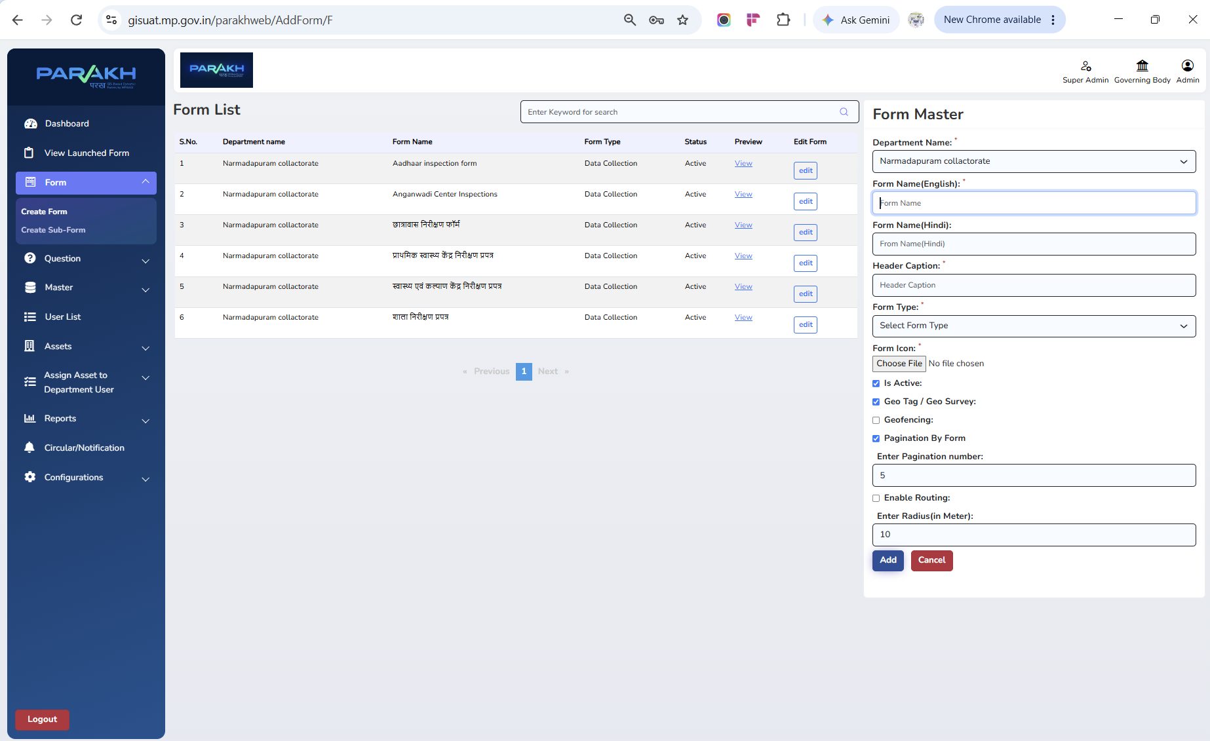
Screen — Form List (left) and Form Master panel (right) for creating a new form. Note the six Anganwadi/Aadhaar/Hostel/School/Health-Centre forms already listed with Form Type = 'Data Collection'.
Field | Purpose
Department Name | The department this form belongs to (e.g. Narmadapuram Collectorate).
Form Name (English) | The form's display name in English, e.g. "Anganwadi Center Inspections".
Form Name (Hindi) | The form's display name in Hindi, e.g. "आंगनवाडी केंद्र निरीक्षण".
Header Caption | Short heading shown at the top of the form on mobile/web.
Form Type | Select "Data Collection" from the dropdown (see Section 1) — this is the key setting that makes the form eligible for frequency-based recurring assignment.
Form Icon | Upload an icon image shown against the form in New Modules on mobile.
Is Active | Must be checked for the form to be usable; unchecking retires the form without deleting it.
Geo Tag / Geo Survey | Enable to require a geo-tagged location capture as part of every submission.
Geofencing | Enable to restrict submission to within a defined radius of the asset's registered location.
Pagination By Form | Enable to split a long form into pages; "Enter Pagination number" sets how many questions appear per page (e.g. 5).
Enable Routing | Enable to turn on map-based routing to the asset; "Enter Radius (in Meter)" sets the buffer distance used when routing (e.g. 10).
- Click Add to save the form once all required (*) fields are filled.
- The new form immediately appears in the Form List with Status = Active and a View link to preview it.

4. Building the Form's Questions — Worked Example: Anganwadi Center Inspection
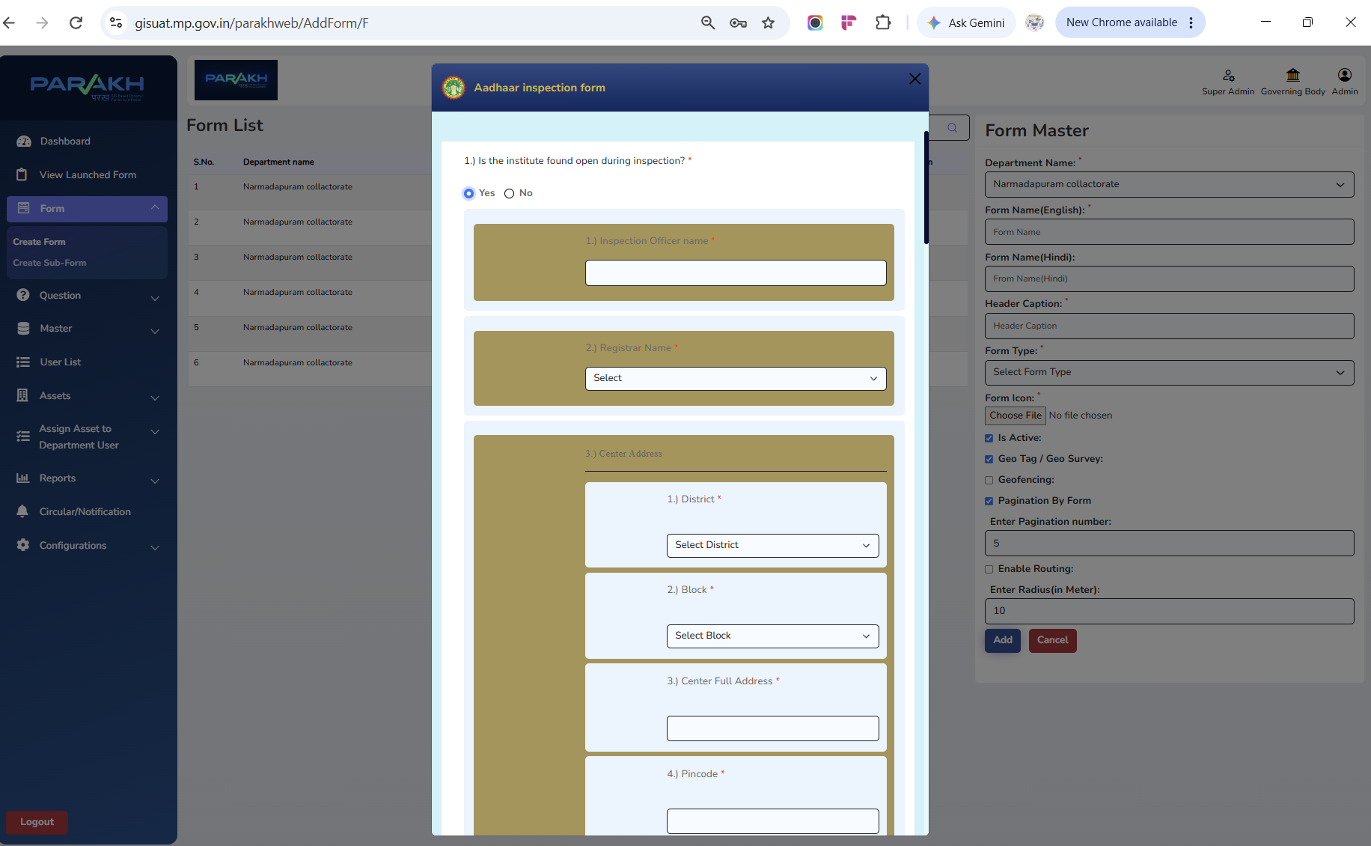
Screen — Form question-builder/preview pattern: Yes/No toggle, text-entry questions, dropdown questions, and a nested multi-field address block (District, Block, Full Address, Pincode).
Question | Field Type
निरीक्षणकर्ता (Inspecting Officer) | Auto-filled from logged-in Inspector's profile (name + mobile number).
निरीक्षण दिनांक (Inspection Date) | Date, auto-captured at submission.
आंगनवाडी केंद्र का नाम (Anganwadi Center Name) | Dropdown/text, identifying the specific center (asset) being visited.
आंगनवाडी खुली पाई गई (Center Found Open) | Yes / No toggle.
कार्यकर्ता का नाम (Worker/Karyakarta Name) | Text entry — name of the Anganwadi worker present.
गर्भवती (Pregnant beneficiaries) | Numeric count — total registered beneficiaries in this category.
धात्री (Lactating mothers) | Numeric count.
6 माह से 3 वर्ष के बच्चे (Children 6 months–3 years) | Numeric count.
3 वर्ष से 6 वर्ष के बच्चे (Children 3–6 years) | Numeric count.
NOTE: These beneficiary-count columns are exactly what feed the PM Poshan-style nutrition-monitoring reporting shown in Section 7 — each monthly visit updates the same four counts for the same center, which is what makes this a genuine "frequency-based" Data Collection form rather than a one-time inspection.

5. Assigning a Data Collection Form — Frequency-Based (Periodic) Assignment
1. Set Frequency — Choose Monthly | Quarterly | Half-Yearly | Yearly. For an Anganwadi/PM Poshan-style form, Monthly is typical since beneficiary counts are reviewed every month.
2. Set From Date and To Date — Define the overall period this recurring assignment should run for, e.g. From 01-07-2025 To 31-03-2026.
3. Preview the Schedule — Click 'View Proposed Allocation Dates' to see every individual visit date the system will generate within that period at the chosen frequency, before committing.
4. Select Department, District, Tehsil, Form and Department User — Choose the Anganwadi Center Inspections form and the Inspector who will carry out each recurring visit.
5. Search and Assign — Click Search to find the matching assets (centers), then assign them to the selected Inspector. Each scheduled date becomes its own allocation record.
NOTE: What this looks like once assignments are running: the Details of Survey and Inspection report (Section 7) shows one allocation row per cycle for the same Asset — for example the same center reassigned on 10-08-2026, then again on 17-08-2026, then 24-08-2026 — each with its own Status (Assigned / Submitted). The exact spacing between dates follows whatever Frequency was selected for that assignment.

6. Filling the Data Collection Form (Mobile — Inspector)
- The Inspector logs into the Parakh mobile app and opens New Modules (or the assigned-work list), where the Anganwadi Center Inspections form appears alongside their other assigned Data Collection/Inspection forms.
- For each due cycle, the Inspector selects the relevant center (asset), which opens the same map/pin flow used for other form types — tap the relevant location pin to open the form pre-bound to that center.
- The Inspector fills the questions from Section 4 — center-open status, worker name, and the four beneficiary counts — capturing photos and GPS location as configured.
- Save as Draft is available if the visit cannot be completed in one sitting (e.g. poor connectivity); Submit finalizes that cycle's record.
- Because this is a recurring form, the same center will reappear as due again at the next scheduled interval (Section 5) — each submission is a separate record, not an edit of the previous month's data.

7. Monitoring & Reports for Data Collection Forms

7.1 State Admin Dashboard
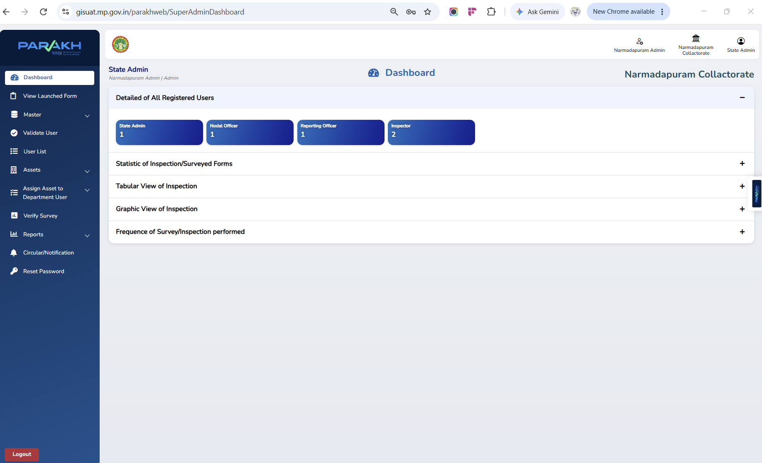
Screen — State Admin Dashboard: registered-user counts by role, plus expandable panels for Statistic of Inspection/Surveyed Forms, Tabular View of Inspection, Graphic View of Inspection, and Frequency of Survey/Inspection performed.
- Detailed of All Registered Users — counts of State Admin, Nodal Officer, Reporting Officer, and Inspector accounts under this department.
- Statistic of Inspection/Surveyed Forms — summary counts of submissions across all forms.
- Tabular View of Inspection / Graphic View of Inspection — expandable panels for tabular or chart-based breakdowns.
- Frequence of Survey/Inspection performed — directly relevant to Data Collection forms: shows how consistently recurring visits are actually happening against the configured Frequency.

7.2 Completed Surveys & Inspection Report
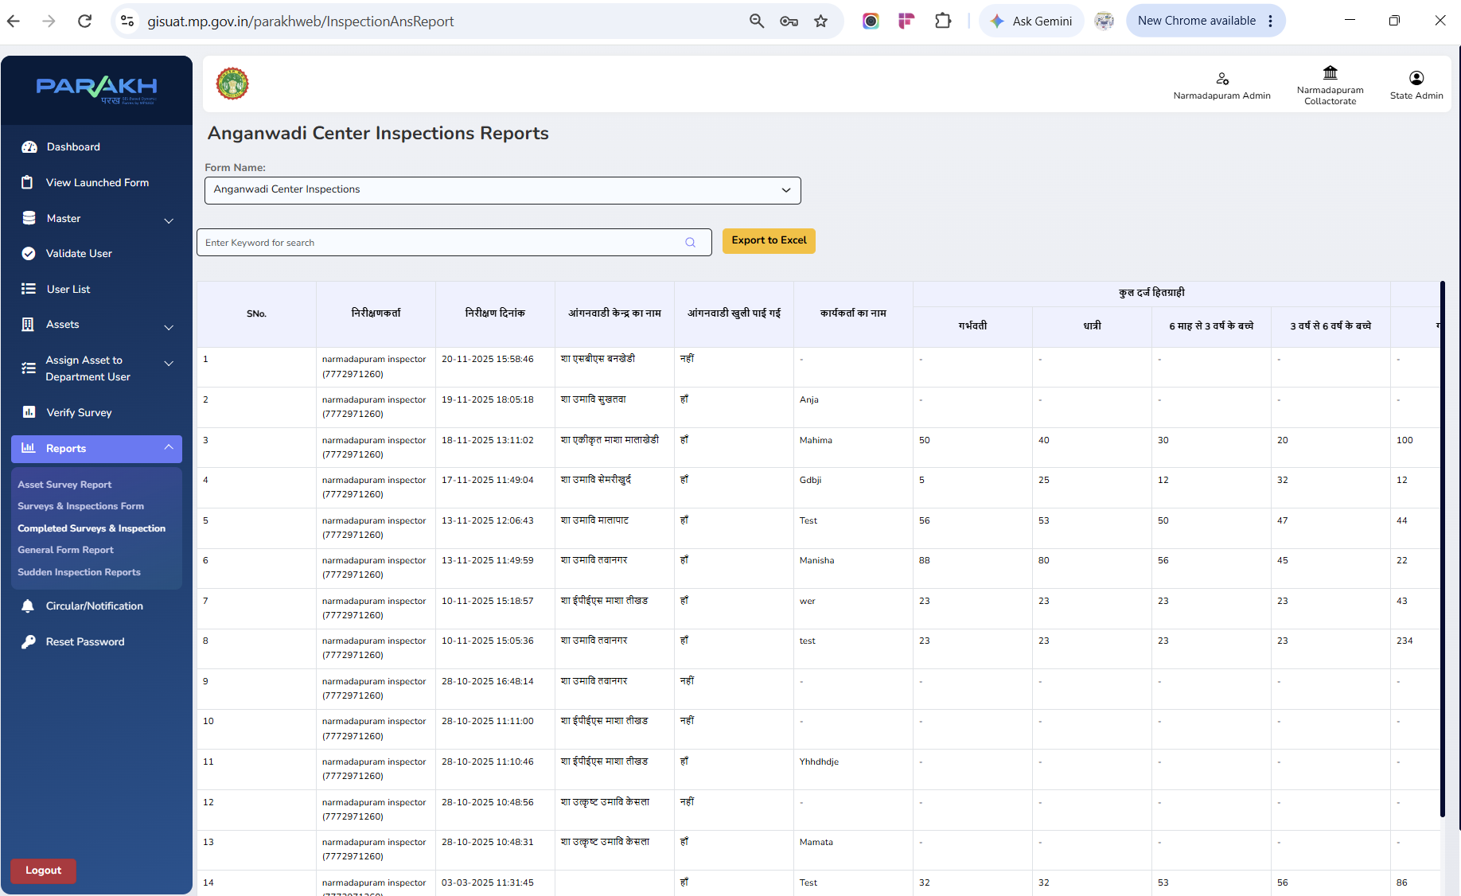
Screen — Completed Surveys & Inspection report for 'Anganwadi Center Inspections', showing per-visit inspector, date, center name, open/closed status, worker name, and beneficiary counts by category. Exportable via Export to Excel.

7.3 Surveys & Inspections Form (Assignment/Allocation Detail)
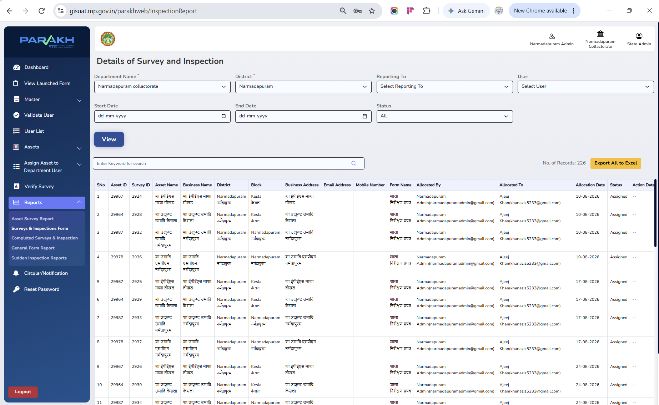
Screen — Details of Survey and Inspection: one row per scheduled allocation, showing Asset, Survey ID, Allocated By, Allocated To, Allocation Date, and Status (Assigned). Filterable by Department, District, Reporting To, User, date range, and Status; 226 records shown for this department alone.
- Use this report to confirm a recurring assignment actually generated the expected number of cycles for the configured period.
- Status = Assigned means the cycle has been allocated to the Inspector but not yet submitted; once the Inspector submits, the record's status updates and the data becomes visible in the Completed Surveys & Inspection report (Section 7.2).

8. Validation & Exception Handling
- Mandatory fields must be completed before a submission is accepted.
- Duplicate entries are flagged by the system.
- Invalid/unauthorised user attempts are logged.
- If survey data is incomplete, the system prompts the Inspector to re-enter it before submission.
- If a user is not yet approved, they cannot access or fill any Data Collection form.
- If there is a network failure mid-submission, data is stored on the device and synced automatically once connectivity is restored.

9. Compliance Note

Appendix — Department Web Login
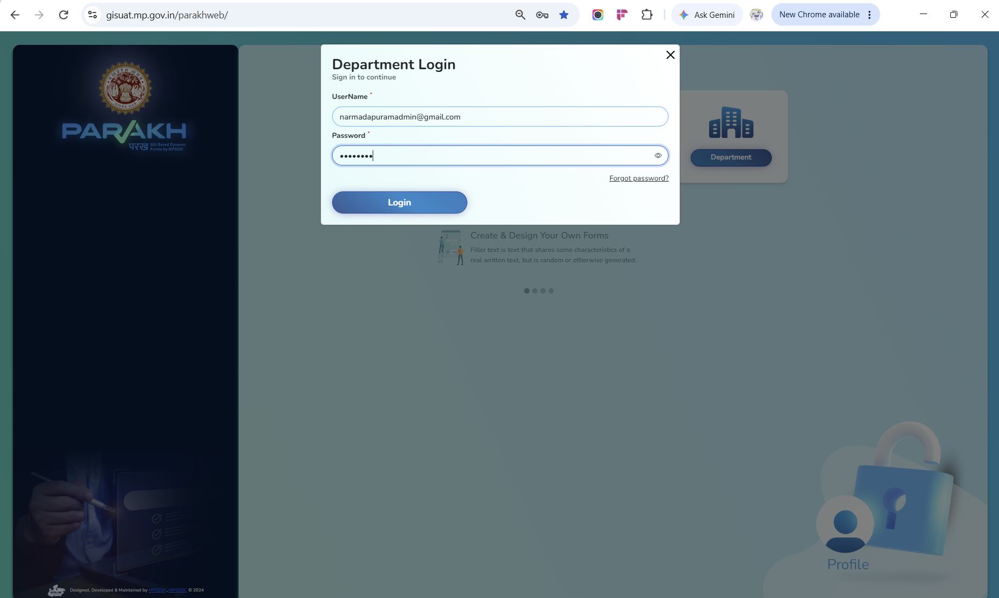
Screen — Department Login (https://gisuat.mp.gov.in/parakhweb/) — select Department, enter Username and Password, then click Login.

